DentSoc Signposting Document 2019
Useful information/services to students

Accommodation services: Security Services:
security@plymouth.ac.uk

01752 588400

Portland square building, Atria A
residencelife@plymouth.ac.uk

01752 588644

Mary Newman Halls

Place to go in the event you lose your wallet or phone on campus. (If it gets handed in, it’ll end up here)

Card and Key office
- Replacement cards- £7.50 will be charged for lost cards
- You'll also find the following services at the University card office:
  - Access - card and keys
  - Student lockers
  - Disabled student parking.
cardoffice@plymouth.ac.uk

01752 588422

Room 6, Roland Levinsky Building
Monday, Wednesday, Thursday 8:30-13:30

IT Services

libraryandITenquiries@plymouth.ac.uk

01752 588588

www.plymouth.ac.uk/about-us/university-structure/service-areas/it-services

Main Campus Wellbeing Centre: Register with the GP

The University Medical Centre is located within the Wellbeing Centre (1st floor).
For emergency medical appointments, contact University Medical Centre on +44 1752 222341.

administration.umcpeverell@nhs.net

01752 222341

Wellbeing Centre, Endsleigh Place, University of Plymouth, Drake Circus, PL4 8AA

Monday-Fridays 8:30-17:00

www.plymouth.ac.uk/student-life/services/student-services/medical-centre-wellbeing-centre

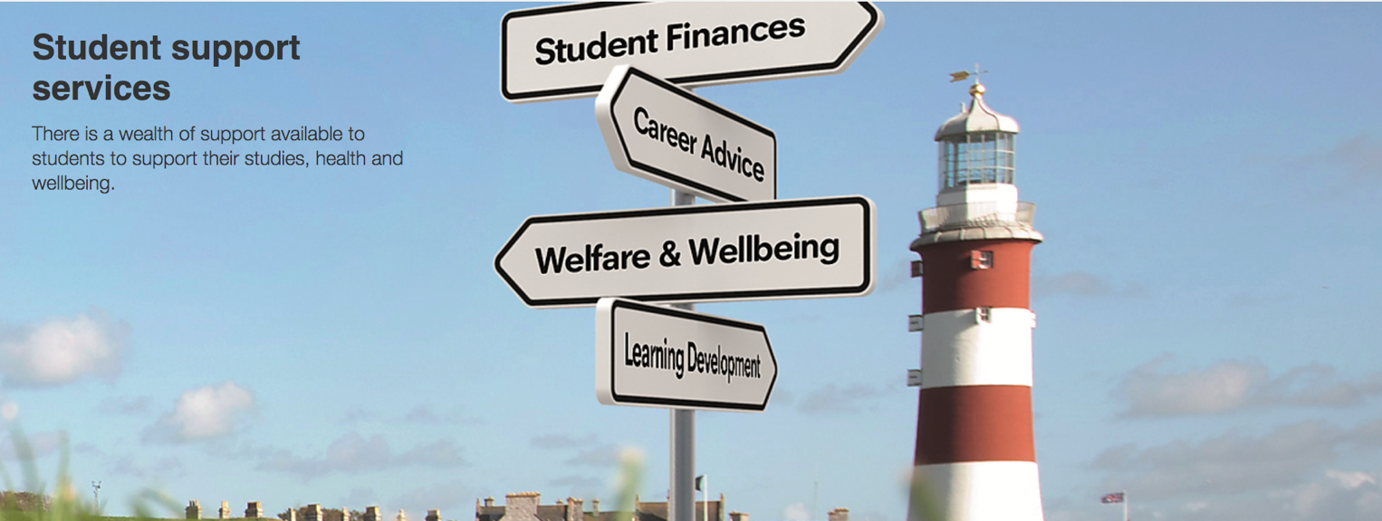
Student funding: support and advice
For help with your student funding enquiries, please go to the ground floor of the Nancy Astor Building

studentservices@plymouth.ac.uk

01752 587676
Monday – Thursday, 8:30–17:00, Friday 8:30–16:30
www.plymouth.ac.uk/about-us/teaching-and-learning/guidance-and-resources/student-support-services

Equality, diversity and inclusion

The University of Plymouth and DentSoc do not tolerate bullying or harassment of any kind.

We want you to be able to bring your whole self to University and not hide any aspect of yourself.

- Student support
- Harassment advisors
- Wellbeing services
- Hate Crime reporting
- UPSU advice

www.plymouth.ac.uk/about-us/university-structure/service-areas/equality-diversity-and-inclusion/student-support

Counselling, E-counselling and Mental Health Appointments

Student wellbeing service

One-to-one appointments and a range of personal development sessions and groups
- Counselling appointments
- Mental health appointments
- E-counselling
- Drop-in service
www.plymouth.ac.uk/student-life/services/student-services

studentservices@plymouth.ac.uk

01752 587676

Student Services Hub, Ground Floor Nancy Astor Building
Monday–Friday, 8:30–17:00 (Wednesday open 10:00, Friday close 16:30)

Anytime advice and mental health helpline:
- Email: assistance@workplaceoptions.com
- Freephone: 0800 042 0134
- iConnectYou App (from iTunes or Google Play. Passcode 34800).

- Available 24 hours a day, 7 days a week, 365 days a year
- In-the-moment emotional and counselling support for all University of Plymouth students

E- counselling:

- Communicating with a counsellor via email exchanges, instead of face-to-face counselling
- Your thoughts and feelings are expressed in password-protected Word documents to be attached to emails you send to us.

Online form to book either counselling support:

https://bookcounselling.plymouth.ac.uk/Initial.aspx?ClickedButtonText=Student+Wellbeing+Services&WebMenuId=1656&CTC=U_WC_3EP0X4O2Z&CaseNoteType=1029&WcSeq=1

Bullying and Harassment

If you experience harassment, bullying or intimidation we can support you; either contact a Harassment Advisor or email equality@plymouth.ac.uk

equality@plymouth.ac.uk

01752 588250

@PlymUniEquality
Reporting a Hate Crime: www.services.devon-cornwall.police.uk/crimereporting/

The Listening Post

Drop-in service for students, staffed by trained volunteers
www.plymouth.ac.uk/student-life/services/student-services/counselling

Meet the volunteers: www.plymouth.ac.uk/student-life/services/student-services/meet-the-listening-post-volunteers

studentservices@plymouth.ac.uk

01752 587676

Student Services Hub, Ground Floor Nancy Astor Building
10:00-16:00 Monday to Friday in term time

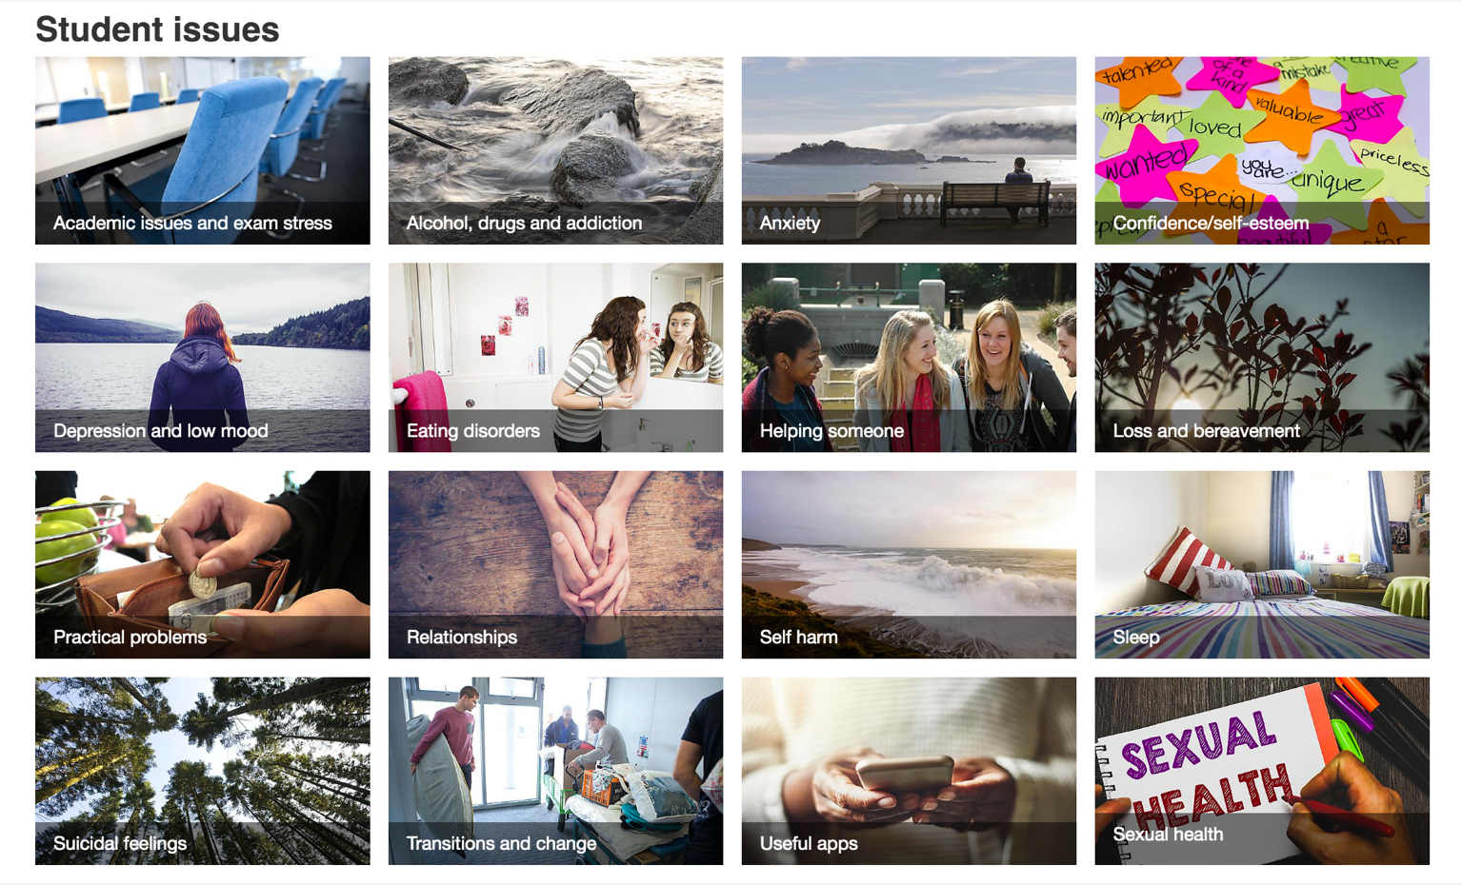
SHINE (Self Help Inspiring E-Resources)

- Resources bank created by students, counsellors and researchers
- Watch, read, listen, find apps and useful links to the best online resources and information about mental health and well-being
- Categorises student friendly content on mental health and well-being

www.plymouth.ac.uk/student-life/services/student-services/shine

SHINE: Academic issues and exam stress

- Mental health charity MIND: Managing stress
https://www.mind.org.uk/information-support/types-of-mental-health-problems/stress/#.VdNS0PlVhBc

- Robert Sapolsky: The Psychology of Stress
https://www.youtube.com/watch?v=bEcdGK4DQSg

- NHS: Student stress self-help tips
https://www.nhs.uk/conditions/stress-anxiety-depression/student-stress/

More resources available via:
https://www.plymouth.ac.uk/student-life/services/student-services/shine/academic-issues

Multi-faith Chaplaincy

Part of Student Services, they are here for everyone on campus – whether you have a faith, are searching for faith, or just want to meet new people
- Support students
- Faith communities and places of worship
- Student religious groups
- Events
www.plymouth.ac.uk/student-life/services/student-services/faith-and-spiritual-support

How the chaplaincy support students:

- A welcoming face and helping hand if you're having problems settling into university life, or at any time during the year
- A team of chaplains and faith advisors who provide help and advice on all faith-related matters, as well as many other areas
- Support through a bereavement or other tragedy
- Lectures and conferences considering ethical and academic issues
- A regular mailing to keep you up to date with chaplaincy events – email studentservices@plymouth.ac.uk if you'd like to receive it.

Where to pray on campus
- The Chaplaincy (1 Kirkby Terrace behind the Rolle Building) has a Quiet Room which is available for prayer and quiet reflection by all faiths and none. The Chaplaincy is open weekdays 10:00–16:00 in term time and 12:00–14:00 in vacations.
- Prayer rooms are also available in 20 Endsleigh Place from 9:00–17:00 weekdays with washing facilities for both genders.
- In addition Sherwell Church is available on Mondays and Wednesdays from 12:00–13:00 for Christian prayer or for quiet reflection. The Church is accessible from North Hill.

Student religious groups

www.plymouth.ac.uk/student-life/services/student-services/faith-and-spiritual-support/student-religious-groups

The University of Plymouth Students Union (UPSU)

- UPSU is a separate entity from the university. It’s a union for students, run by students.

- For advice and support during your time at the university, the appropriate members of the elected committee are there to help.

- You can contact any member by using their student e-mail:
first name.last name@students.plymouth.ac.uk

www.upsu.com

